Content Marketing and Social media plan for:

LAVA MOBILES

URL: <https://www.lavamobiles.com/>

INDUSTRY: Mobile industry( India’s mobile company)

#Social Media Accounts :

* Facebook: <https://www.facebook.com/lavamobiles>
* Twitter: <https://twitter.com/LAVAMobile>
* Instagram: <https://www.instagram.com/lava_mobiles/>
* Pinterest: <https://www.pinterest.com/lavamobiles/>
* YouTube: <https://www.youtube.com/user/LavaMobiles>

#Auditing of website:

My client is largest domestic distributor of the mobiles in India. The content of there buisness is distributed all around the asian sub-continent.

# Followers in their Social Accounts :

* On Facebook : 1,142,943 followers
* Twitter: 61k followers
* Instagram: 55.3k followers
* Pinterest: 253 followers
* YouTube:281.1k followers

My client is not usuallly active on pinterest because it doesn’t meet there buisness goal. Maybe because they doesn’t has any visual contents.

# Curent content marketing strategy opted by my client:

1. My client currently is targeting #AtmaNirbharYojna of Indian government and Digital India movement of HRD ministry.
2. My client want to expand its buisness in the neighborhood countries also, they are trying to get ibnvolved in there social issues using twitter .
3. The technical strategy revolves around creating Blogs about there latest technologies and development in mobile marketing world.

#Updated content marketing plan:

1. Suitable platform:

Selecting a suitable platform to exhibit your website in the form of content and building relations.

1. Guest posting:

By posting a supreme content on high authority site helps gaining visibility.

1. Seeking influencers:

To attract large audience, building potential relationship with influencers brings lot of values.

1. Anchor content or anchor text:

A content that serves as the core of any campaign. Anchor content is a piece of content that drives huge amount of traffic because of its uniqueness. It is often a comprehensive guide on a problem that your target audience is looking for.

According to me my client should use these four key strategy. My client usually is active on the social media but only sharing there post would not generate any links and my client doesn’t have any B2B relations which make it suffer in getting links from good websites.

#Example of Content Marketing Plan:

As discussed earlier using good Blog post will help not only in enhancing your website authority by getting good scoring links but also in gatherinh your audience or customer. Creating good blog post on currently outgoing development in there industry will create great impact on there market.

This is the example of blog post created by Xiomi which help in developing there SEO and marketing strategy. Moreover you can see that the post created doesn’t have technological aspect .

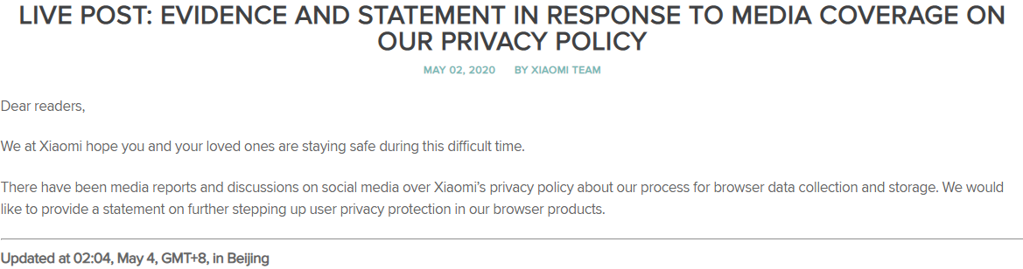

Another example is of the VIVO India, here in the blog post media is about there incoming Mobile before its launch. Which created there market value in advance and generating audience and buyers of there product.

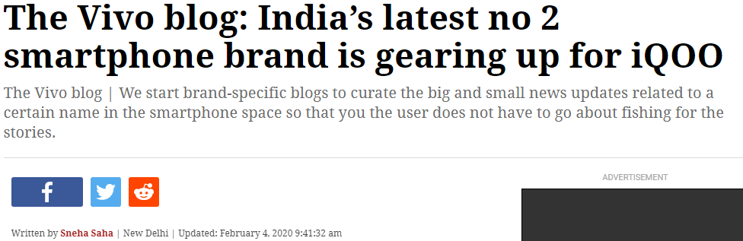

**#Creating a new social media plan:**

Social media supports the development of a company’s online reputation and visibility, which ultimately helps with SEO. By analyzing audience demographics and choose the appropriate social media platforms for our intended audience. And finally, we will use successful social media strategies to build our audience and create audience engagement.

List of influencers :-

**1.** 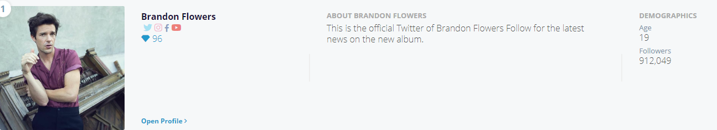

2. 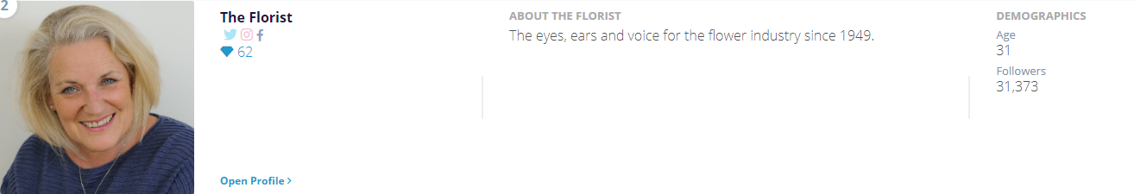

3. 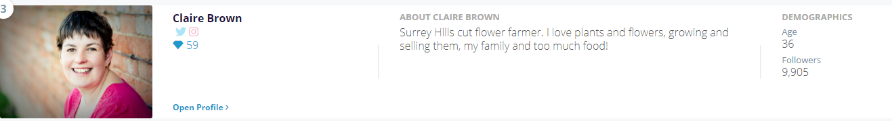

Influencers have large audiences and this is a really important thing because we want to be able to build our own audience and we want to have access to other people's audiences, and influencers can give you that. They gets more shares and more links out of the same size audience.

-Gaurav Todwal